Name : Ida Bagus Ketut Yoghantara

Module : Programming Foundations (Java)

Class : BDSE04-0322

**PROJECT REPORT**

1. **Project Background**

The background of this project is the company want to expanding their market into the Information Technology subject areas. The company want their internship to make and producing software development to assess the subject knowledge. As the internship, they want the internship to make them a MCQ System for the given scenario as below

1. The system should handle multiple sets of MCQs. For example, Java Basics, Control Structure, HTML Basics, etc.
2. After selecting the set, the system should display the questions from the selected list
3. Let the users answer and calculate the score based on their answer. For example, the score should be 90% when the user answers 9 questions correctly out of 10 questions.
4. **Task 1**
5. Briefly describe what an algorithm is and design an algorithm to process the form inputs and outputs of the process in the project scenario.

**Solution:**

Algorithm is a technique or procedure that is used to solve a problem. It works by having your computer perform a series of prescribed actions that describe how to do something and your computer will execute it exactly the same way every time. An algorithm operates by following a set of instructions made up of inputs. Once it has followed all the inputs, it will see a result, also known as output.

Algorithm design for project scenario:

1. Take username input
2. Generate MCQ Set name by the CSV file name without the extension to the user
3. Take user input for selecting MCQ set
4. If user selecting non-existence MCQ set, give user a warning and repeat step 3
5. Display question and the multiple choice according to user input from selecting the MCQ set
6. Take user input for their answer
7. If user inputting non-existence multiple choice, give user a warning and repeat step 6
8. Compare user answer and correct answer from the CSV file
9. If user choose the correct answer, add user score by 1  
   else display the correct answer and count the wrong answer by 1 per wrong answer
10. Repeat from step 5 until the 10 questions from the CSV file answered by the user
11. Print the score multiple by 10 and display user name, user right answer counter, and user wrong answer counter
12. **Task 2**
13. Explain briefly Procedural, Object Oriented and Event driven paradigms, Give example of programming language which will be used to implement each of them.
14. What programming paradigms you use for this project?
15. Document the architecture of the System along with Module and its Components description.

**Solution:**

**1. Procedural Programming**

Procedural programming is a programming technique which derived from structured programming and also is based on the concept of invoking procedures. Procedures, often known as routines, subroutines, or functions, are essentially a set of instructions to be followed. Any procedure in a program can be invoked at any time during execution, either by other procedures or by the program itself.

Programming language which used to implement procedural programming are:   
FORTRAN, ALGOL, COBOL, BASIC, Pascal and C.

**Object Oriented**

Object-oriented programming (OOP) is a programming paradigm that is built around the concept of objects. Data is stored in the form of attributes, while code is stored in the form of methods. Computer programs are developed utilizing the concept of objects that interact with the real world entity in object-oriented programming. The most popular object-oriented programming languages are class-based, which means that objects are instances of classes, which also determine their types.

Programming language which used to implement Object Oriented are:   
Java, C++, C#, Python, PHP, JavaScript, Ruby, Perl, Objective-C, Dart, Swift, and Scala.

**Event Driven Paradigms**

The focus of event-driven programming is on events. Eventually, the program's flow is determined by occurrences. Until far, we've dealt with sequential or parallel execution models, but an asynchronous model is one that incorporates the concept of event-driven programming. An event loop that is always listening for new incoming events is required for event-driven programming. The success of event-driven programming is contingent on the occurrence of certain events. Once an event loops, it is up to the events to decide what to do and in what sequence to do it.

Programming language which used to implement Event Driven are:

Visual Basic, C++ and Java.

**2.** Programming paradigms used in this project is Object Oriented.

**3. Documenting Architecture**

* Project (Folder)  
  Consist of all project files
* src (Folder)  
  Folder to store all the source code
* MCQ (Folder)  
  Folder to store all the CSV MCQ Set files
* Main (java class)  
  Main Class of the program
* MCQ (java class)  
  MCQ System program consist all the functionality of the program

**3. Task 3**

1. Provide the source code of implementation for the algorithm written in Task 1.
2. Provide a brief note on how the algorithm is translated to equivalent code.

**Solution:**

**Step 1**

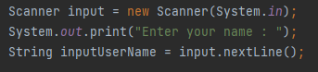

Taking user input using “Scanner”, user will be required to be inputting their name in the first time the program started.

**Step 2**

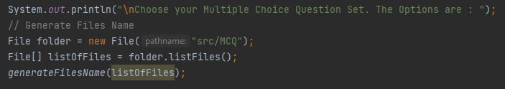

Using “File” Class imported from java.io.File, read all the files in the MCQ folder and get all the list of files, after that here we are using method called “generateFilesName” that given parameter of listOfFiles array.

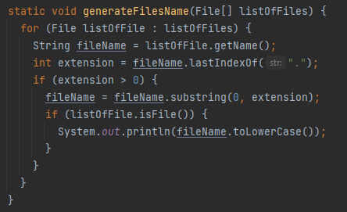

In the method “generateFilesName”, loop through all the files and print all the file name into the console without the extension.

**Step 3**

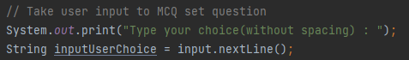

Taking the user input for them to selecting the MCQ

**Step 4**

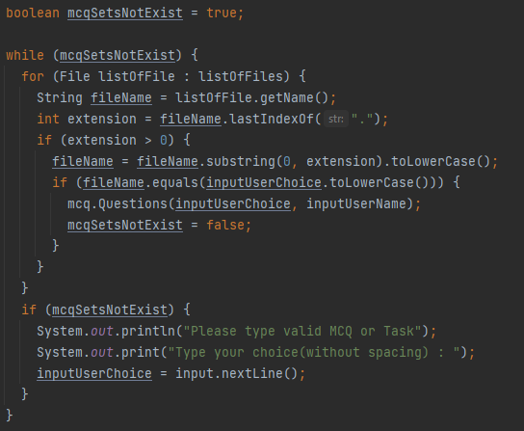

Cheking user input if they inputting invalid MCQ or Task

**Step 5**

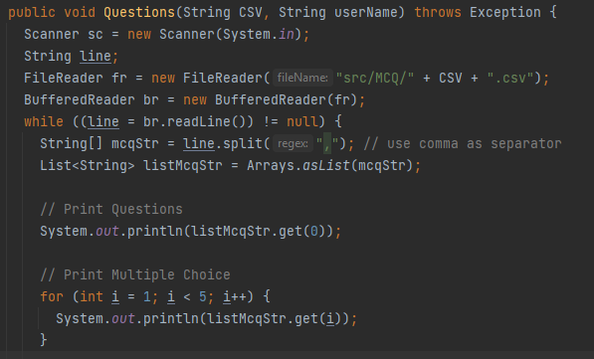

Displaying the question and the multiple choice according to user input after they select the MCQ or Task.

**Step 6**

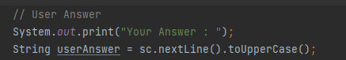

Taking user answer

**Step 7**

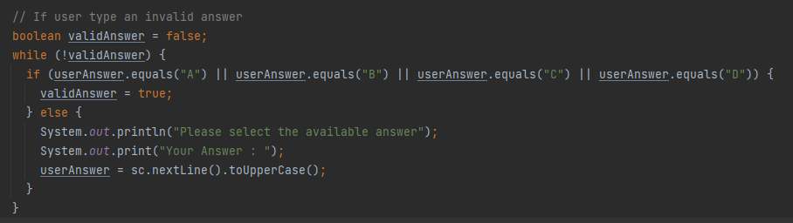

Checking if the user inputting valid answer or not

**Step 8 & 9**

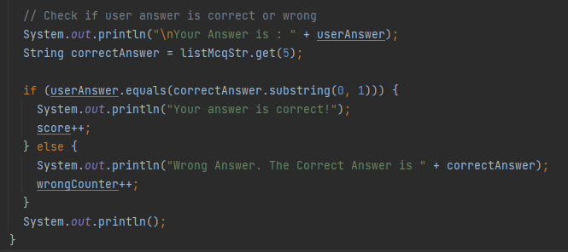

Comparing the user answer and the correct answer, if user choose the correct answer they will get 1 score

**Step 11**

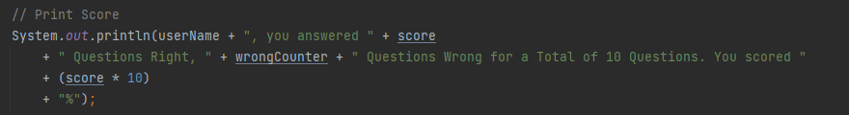

Printing user score and let them know how many answer they get correct and wrong.

1. **Task 4**
2. Briefly explain how you have used object oriented features to build the application. Provide sample source code and explain how you have used object oriented features to create a particular functionality.

**Solution:**





Object Oriented features that used in this project is using the default constructor to make an object of MCQ to the main class. Using this object you can called the method from the object.

1. **Task 6**
2. Explain briefly 5 features which are available in IntelliJ or Eclipse, which you use to build this application.

**Solution:**

1. Auto complete code  
   Using this features help the development more easily and fast.
2. Code analysis  
   This features helps to improve the code by identifying that an expression is valid or not and gives a warning or compilation error.
3. Detecting duplicates  
   Helping to find the duplicate code and give the suggestion to the user.
4. Shortcuts  
   Keyboard shortcuts in intelijj IDEA help a lot when writing a program.
5. Navigation and search  
   Looking piece of code in the hundreds of line will make us feel unpleasant, but with this features we can just search the respective code that we want to search.
6. **Task 8**
7. Explain briefly how using an IDE is better than not using an IDE.

**Solution:**

Not using an IDE is old way to write a code, it will be challenging and more harder than using an IDE. IDE provides you a lot of features such as syntax highlighting to help better understand and read the code, auto completion that make the development more faster and less syntax error, and lot more of features. IDE also built in compiler that you can use for faster development.

1. **Task 9**
2. Explain briefly the steps involved in debugging and how does it helps to develop more secure and robust applications.
3. Provide screen capture of the process with break points.

**Solution:**

Debugging with breakpoint helps to identify error better, in this case variable listOfFiles might be null and still running without error, so after debugging with the breakpoint the code will be repaired to make it more secure and robust applications.

